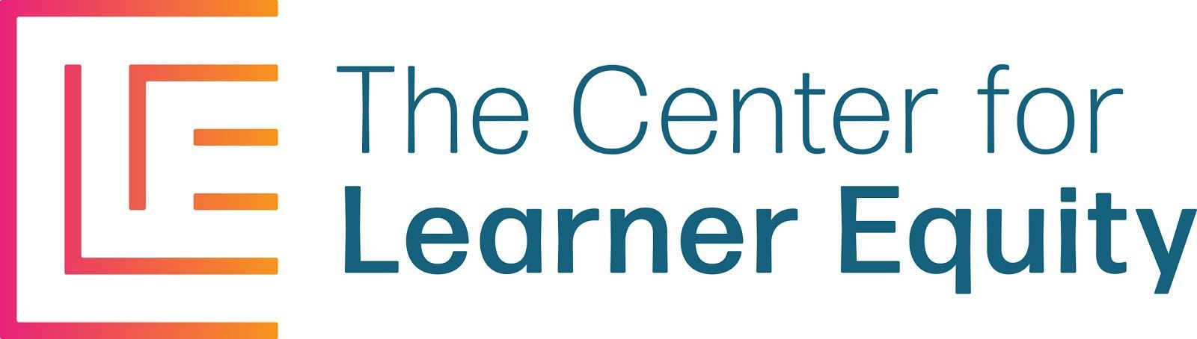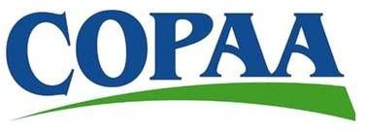
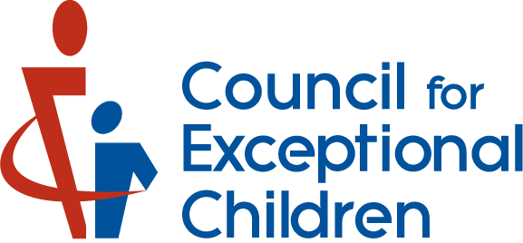
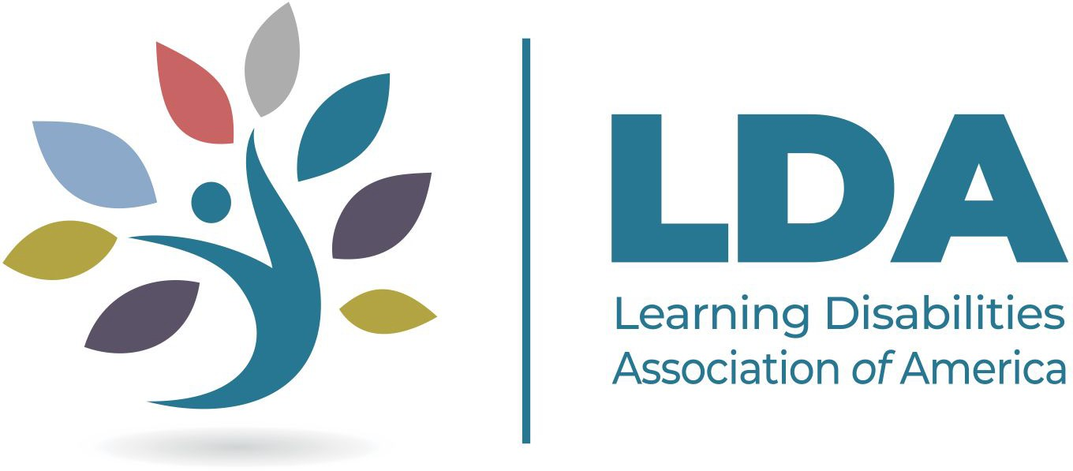
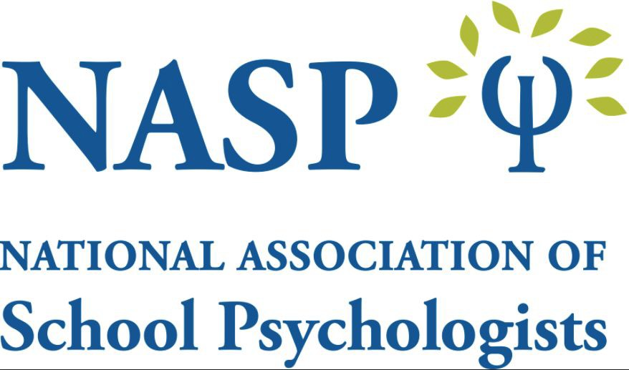

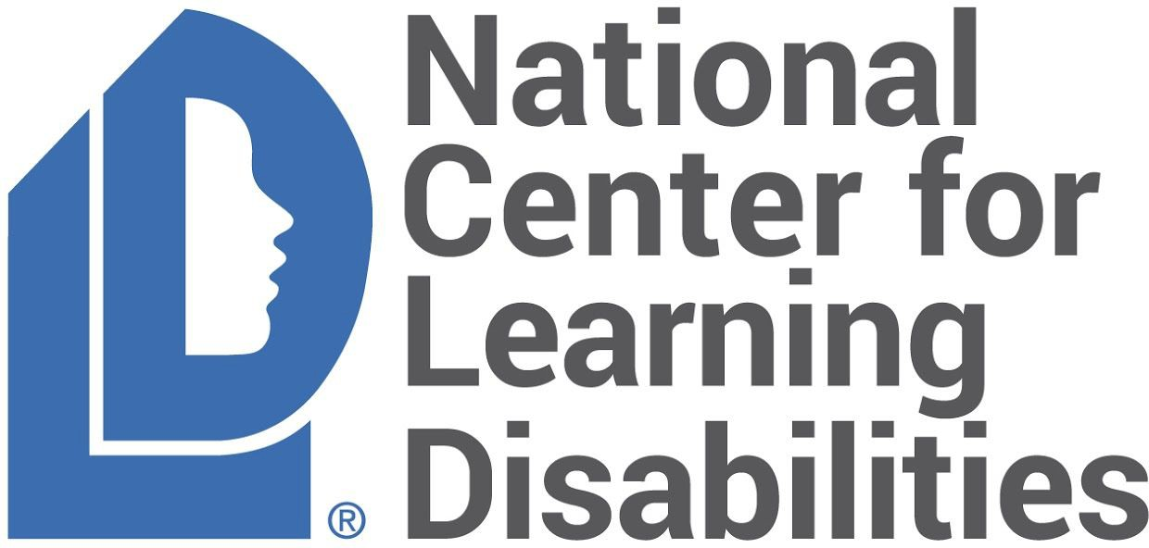
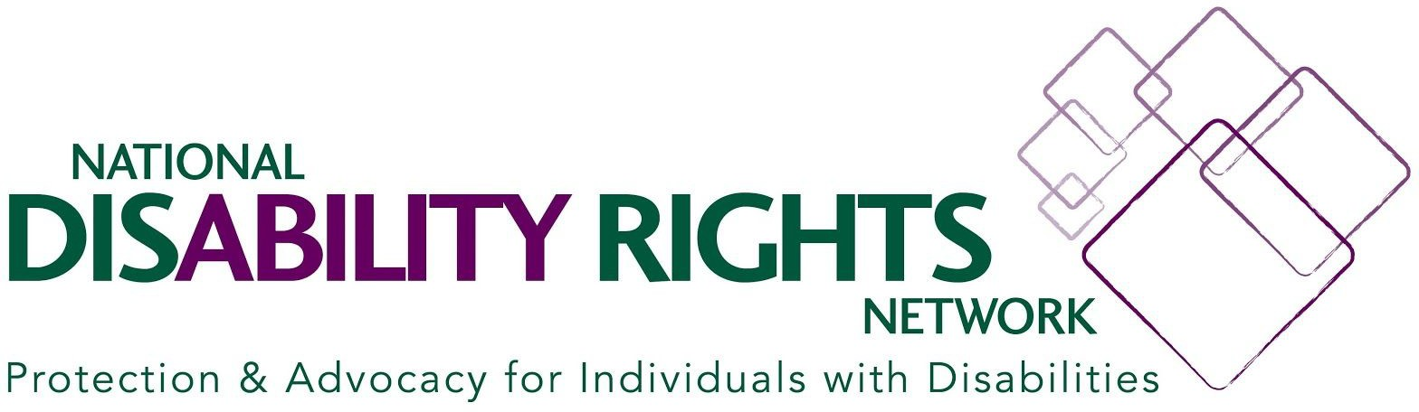

9 Recommendations for Inclusive Learning Recovery for Students with Disabilities
Over the past year, many students have experienced entirely virtual and remote learning and many—especially students with disabilities—will need additional support, time, and teaching to get the high quality education they deserve.

Students have missed out on opportunities to learn and develop during the pandemic. In response, the federal government is providing billions of dollars to address “instructional loss”. While states, districts, and schools pilot new approaches to promote learning recovery, these practices must be held to high standards, be accessible and inclusive to students with disabilities, and must have educators prepared to serve students with disabilities effectively and equitably.

As organizations focused on supporting students with disabilities, their families, and the educators who serve them, we have identified the following recommendations as necessary to maximize the impact for students with disabilities and ensure equitable access to strategies for learning recovery:

Ensure all students have equal access to all learning recovery programming and are meaningfully included.
Any instructional loss programming should be accessible and available to all students
regardless of their disability status. Students with disabilities will have a variety of

needs and may need different types of accommodations and support to access learning recovery programming. Such needs must be met and the programs must be designed to include all students with disabilities.

Ensure all students are educated in the Least Restrictive Environment.
Learning recovery programming should be designed to support all students who have missed out on crucial core (or Tier 1) instruction during the pandemic. The majority of students with disabilities spend most of their day in general education settings. Thus, learning recovery programming should also be done in the least restrictive environment (as required by IDEA), alongside general education peers to the greatest extent possible. Programs should not be designed to serve students with disabilities in separate settings from students without disabilities. If students were previously spending the majority of their time in general education classrooms, learning recovery programming must not be an avenue to segregate these students.

Recognize special education services are separate and apart from learning recovery programming.
The goal of learning recovery programming, as a service that is being offered to all students, should be to help students meet grade-level standards; or for students with significant cognitive disabilities, to help them make progress in the grade-level curriculum based on their abilities. The purpose is to bolster the delivery of core (or Tier 1) instruction. This programming should not supplant special education services outlined in a student’s individualized education program (IEP) or 504 plan. Rather, this programming should supplement regular instruction to get students back on track to meeting goals aligned to grade-level standards. Schools and districts should not conflate compensatory education services with instructional loss programming, as students may be found eligible for compensatory services¹ and should still have access to additional instructional loss programming.

In addition, extended school year services (ESY) are also separate and apart from learning recovery programming that is initiated due to the pandemic. Any services that have been agreed upon that include time outside of the typical school schedule should still be done along with any learning recovery programming.

Incorporate inclusive progress monitoring practices within learning recovery programming.
Programming to promote learning recovery must be accompanied by meaningful progress monitoring practices. Progress monitoring can be used to determine if the
¹ In general, a student has the right to compensatory services if there’s a denial of a free appropriate public education. Compensatory instructional time should focus both on progress in the general education curriculum and IEP goals and be in addition to any learning recovery programming. For more information, visit the Council of Parent Attorneys and Advocates “FAQ on Compensatory Education in the time of COVID-19”

programming is effective, and to identify students who may benefit from different approaches or interventions. For some students, simply providing additional hours of instruction may not be sufficient. Thus, progress monitoring must be used to ensure that all students are making progress toward grade-level standards.

Enable meaningful collaboration between professionals.
Students with disabilities will have an individualized education program (IEP) or 504 plan that lays out the unique supports and accommodations the student needs.
However, the personnel who are staffing the learning recovery programming may not be involved in the student’s IEP team. For example, the program might be staffed by AmeriCorp volunteers or tutors from other community based programs who don’t have the same training and experience as the IEP team or school professionals. Therefore, there should be ongoing communications and coordination between program staff, educators, families, and specialized instructional support personnel. Where a student may need unique supports, the IEP team should ensure the professionals providing the learning recovery programming have the knowledge and skills to provide those supports.

Create opportunities for inclusive and purposeful stakeholder engagement.
Any implementation of a learning recovery initiative should involve input from students, families, and other stakeholders representing the disability community. Failure to implement new school initiatives without the consultation of students with disabilities, their families, or special educators can result in a retrofitting the program to attempt to meet the needs of students with disabilities rather than meaningful inclusion and accommodations being made at the onset.

Provide inclusive and transparent data on learning recovery programming.
Learning recovery programming should be required to report on enrollment of students with disabilities and other underserved subgroups of students and to accurately measure and track results for student subgroups. It is essential to publicly report this data and know how the programs are serving students with disabilities. Other important data to collect, particularly where these programs are run outside of the school day and at locations other than a student’s neighborhood school, include attendance and student engagement, discipline, bullying, and access to social/emotional and mental health supports. This data should also be disaggregated by disability category whenever possible.

Align resources equitably and efficiently.
States, districts and schools should invest in recruiting and retaining specialized instructional support personnel to staff learning recovery programs. Districts should also prioritize and invest in the implementation of Universal Design for Learning (UDL),

multi-tier systems of support (MTSS), positive behavioral interventions and supports (PBIS), social/emotional programming and instructional loss initiatives that use evidence-based and inclusive instruction. Where these programs are staffed by community organizations who do not employ educators, schools, districts, and states should also invest in providing professional development to any program personnel (tutors, mentors, camp counselors, reading partners, etc.) to better understand disabilities, accommodations, universal design for learning, progress monitoring, and evidenced-based approaches to effective instruction for students with disabilities.

Invest in inclusive and actionable research.
There is an urgent need to identify strategies that work to promote learning recovery at the scale resulting from the pandemic and to scale effective, research-based models that accelerate learning and improve outcomes for students with disabilities, now and in the years to come. There is also a significant need to understand the academic, social, emotional, mental, and behavioral impact this pandemic has had on students with disabilities and the educators that work closely with them. It is essential to invest in research that studies:
  - the rate in which students with disabilities were bullied and harassed in virtual environments and positive ways to mitigate the impact.
  - which students, particularly those with disabilities, thrived during virtual/remote learning, what circumstances were present, and how to continue the positive outcomes that may have occurred for certain students.
  - which learning recovery initiatives had the most success in terms of academic, social/emotional, and behavioral outcomes for students with disabilities.
  - the capacity of schools to help students “catch up” academically after many students received a full year of virtual/distance learning while also prioritizing social and emotional learning.
  - the impact of the pandemic on school personnel, including recruitment and retention as well as the exacerbation of existing shortages.
  - promising practices to transition students back into the classroom after long absences, particularly those with disabilities that impact behavior, emotion, and regulation.
  - the rate in which students did not engage in any learning activities and strategies to connect students back into the school community.

For more information, please contact:
Meghan Whittaker, Director of Policy & Advocacy mwhittaker@ncld.org

