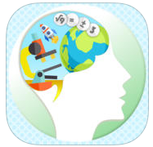
Brain Injury Strategies App
Published on iTunes: https://itunes.apple.com/us/app/brain-injury/id1119205616?mt=8 or
http://tinyurl.com/jcocem4 (Currently available for iPad only)

NEW- Published on Google Play: https://play.google.com/store/apps/details?id=com.kihdapps.brain_injury or http://tinyurl.com/hfph6he
The free Brain Injury Strategies App is intended to provide ideas for supporting an individual who is returning to learning. It addresses various areas of concern that can happen after a concussion, a type of traumatic brain injury. The end product is a summary of selected strategies that can be implemented by an educator for an individual student. (Note: To preview the Brain Injury Strategies App, use 1234 as student ID)
