Parents’ Guide to Special Education Dispute Resolution App
(“SE Resolution”)
Virginia Department of Education

Published on iTunes: https://itunes.apple.com/us/app/parents-guide-to-special-education/id927590038?ls=1&mt=8​ or http://tinyurl.com/hydqkff

Published on Google Play: https://play.google.com/store/apps/details?id=com.kihdapps.policyapp&hl=en
or http://tinyurl.com/hmetgy8

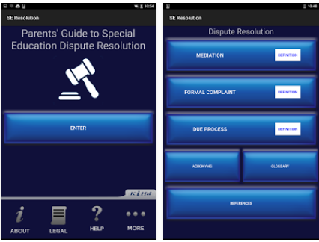
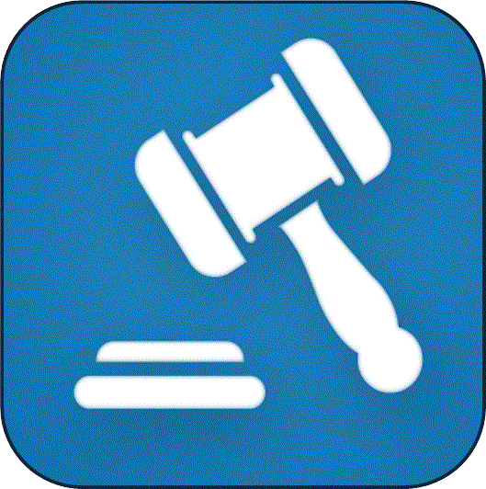
This free App renders the "Parent’s Guide to Special Education Dispute Resolution" by the Virginia Department of Education (VDOE), for mobile devices. It covers "Mediation," "Formal Complaint," and "Due Process" and includes a section that defines relevant "Acronyms" and a "Glossary." The application offers an easy to use question and answer format. Many answers include a direct link to the Regulations Governing Special Education Programs for Children with Disabilities in Virginia. It is designed to help parents and educators better understand their rights and responsibilities during the dispute resolution process.

