Moving to online/home instruction
Q & A for Intervention Specialists working with learners who have complex needs

Q: What were you in the process of teaching before schools moved to home instruction? What activities did you have planned? What standards were you in the process of covering?

A:
- Stick with the plan but think flexibly.
- Send home any materials (digitally or in take-home packets or blizzard bags) that were created for learners to use during instruction. Record small videos or short hold live video conferences with students to teach and demonstrate/model.
- Break activities into small chunks that can be completed over multiple days in small segments of time – no more than 15 minutes
- Add in familiar tools and strategies that students will be able to use independently

Q: What were you planning to teach next month, and the next and the next? What units of study were coming next? What standards still remain untaught?

A:
- There have been many new digital resources that have been shared via social media. Sift through resources to find material that may be used in teaching the upcoming topics/content.
- Design new materials and learning opportunities in the format described in the question above.
- Select materials/manipulatives that might be available at home or send materials to families in resource toolkits.
- Offer a choice card or chart that allows students and families flexibility in choosing learning activities that match resources at home.
- Think fun! Think movement! Think creative! When designing activities.
- Support all activities with access tools and features. Make sure all activities are accessible to all students. Some students may need additional supports.

Q: What daily schedule were your students used to following? How can it be adapted to work in a home environment? Note: Think ease of use for families and flexibility.

A:
- Share your weekly schedule with families, including times of day. Some students will need to continue familiar routines as much as possible.
- Model the use of visual and tactile schedules, task analysis and first/then systems with families as needed.
- Take pictures of object schedules that families could possibly replicate at home. Repurpose home objects to create tactile schedules and/or schedule or calendar boxes. For example, use a set of drawers, plastic containers or a group of boxes arranged in a linear row to represent different times of day or days of the week. Each drawer or box would contain tactile items/symbols to indicate the next task or event.
- Create an adapted version of the daily schedule that offers flexible options rather than single choices.
- Share the first/then strategy and tools with families.
- Communicate with families that the schedule can be as flexible or as traditional as they need it to be to meet their needs at home.
- Share alternate versions of the daily schedule that students can use as they would at school.
- Suggest the use of timers at home if they are used at school. (phone/watch timer, egg timer, sand timer, digital online timer, etc.,)
- Look online to access and create visual schedules. Companies like Boardmaker have offered many free examples and access to their software during this time.
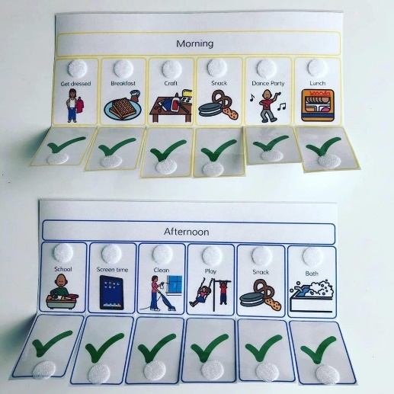

Q: Were there in-task schedules, task analysis, first then choices/boards that might be needed by learners and families to complete tasks and build learner independence? Can those be emailed, gathered from school or printed and sent home?

A:
- Gather up and send home as many of these tools as possible and send them home with students.
- Send digital copies of these tools home to families if they can print them.
- Use adapted versions of these tools using found objects in the home as described above when needed.
- Work with families and other school staff (paraeducators, therapists, aides, etc.,) to create tools for support in the home.
- Send assistive technology tools used in the classroom home for use during school closure.
- Check in with local lending libraries to see if they have and can ship assistive technology tools home for short term use.

Q: Are their digital resources that can be used in place of traditional class materials?
Example: teacher read aloud – use online videos or livestreams of storytellers
Example: using manipulatives – virtual manipulatives
Example: field trip – virtual tours and experiences
Example: paper materials – digital materials using teacher created, free access or short-term trials

Q: How do we develop transition/functional skills across home, work, community during school closure?

A:
- Pair everyday skills together with academic skills.
- Include these skills in the daily schedule.
- Some work and community skills can be simulated online.
- It's a great time for research and collect strengths and needs: have students and families track everyday skills that are challenging and those that are independent during time at home.
- Watch videos of different jobs and select a few that the student might be interested in pursuing.

Q: How do we help families and students maintain emotional and physical health during time at home?

A:
- Remember movement in both activities and daily schedule. Schedule twice as many breaks/recesses as usual.
- Suggest ideas for movement in and around the home. Remember: some of these activities can also be functional skill development. (I.e. sweeping, dusting, year work, laundry, dishes, cooking, exercise videos, homemade obstacle course, change sheets on the bed, take a shower/bath, walk the dog, clean out animal stall or pet cage/tank, etc.,)
- Don’t forget the arts. Ideas: music, dancing, singing, playing games, puppet shows, mini-plays, make arts and craft projects, make sensory materials like playdough or glitter jars, coloring pages, movement activities, stretching, play homemade or real instruments, play piano, make mud pies, go on a nature walk and make art, baggie books or windchimes with found objects, etc.,.
- Check in and maintain as much or as few communications are requested by the family.
- Try to connect students with other students, if possible.
- Try to connect students with other staff members, if possible.
- Share enough resources and information to set families up for success, but not too much that might overwhelm them.
- Loosen the rains on expectations.
- Offer families access to contact information that they can use in their time of need.

