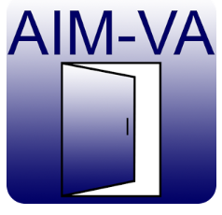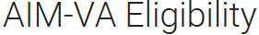
Published on Google Play or http://tinyurl.com/zhoabfc

Published on iTunes or http://tinyurl.com/gpsu2oe

This app is used to determine if a student is eligible to receive and use accessible instructional materials created by AIM-Virginia. It is designed to work independently or as an extension of the AT Consideration Guide app developed by KIHd (Kellar Institute for Human disAbilities).
