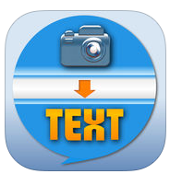
EZPic2Txt App

Published on iTunes: https://itunes.apple.com/us/app/ezpic2txt/id1179048713 or http://tinyurl.com/z7oohn6
This texting app provides a picture-based system for individuals with disabilities, who are non-readers or who are not able to text using a standard touch screen keyboard. The user can send important preset message(s) (created by a family member or supervisor) to necessary preset contact(s) as email messages or text messages with one swipe or touch. Users can also receive messages sent to them by others using this app. Messages sent or received by the user can be read out loud using text-to-speech technology. (Feb. 2017)

