I Can Stay Healthy by Wearing a Face Mask

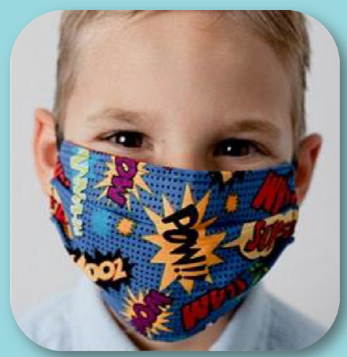
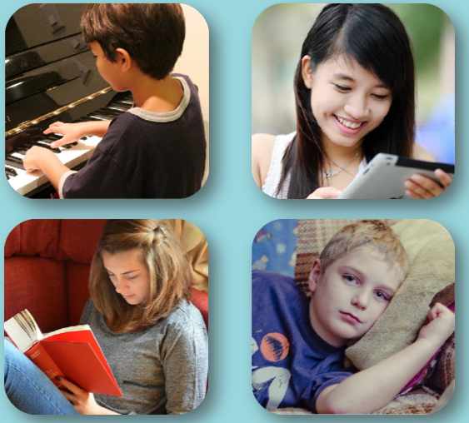
I have been staying at home more because of the coronavirus. The coronavirus are germs that make people sick.

Coronavirus germs are so small that I can’t see them.

Coronavirus can be passed from person to person and make me and other people sick.

That is why I can’t go to the places I usually do.

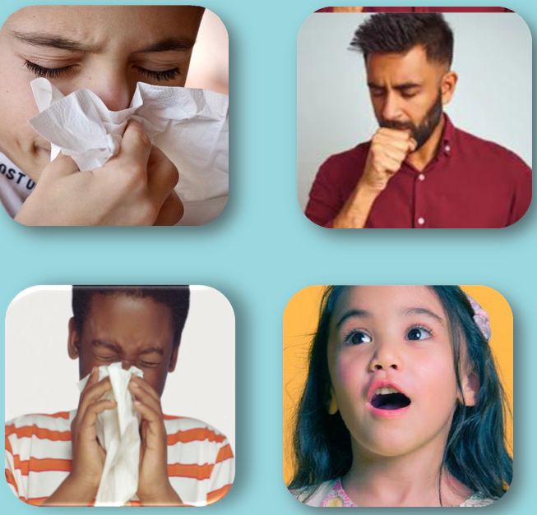

The coronavirus can be spread through the air.

Some ways that it spreads are when people breathe, cough or sneeze.

Wearing a face mask is an important way I can prevent coronavirus from spreading.

When I leave my house, there are many places I should wear a face mask.

Most of the time, these places will be where
there are groups of people in one place.

There are different types of face masks.

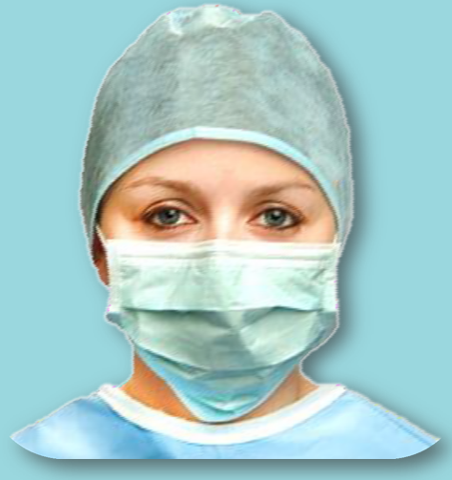

Doctors, nurses, and others who work in health care wear certain types of face masks.

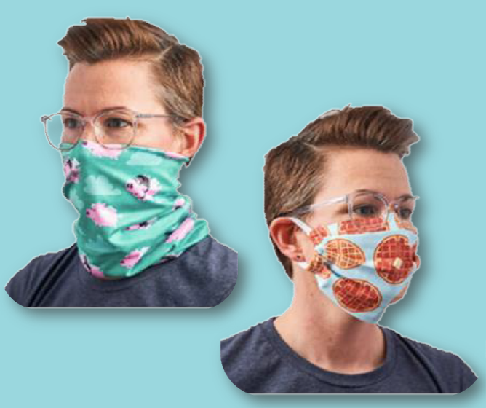
There are other types of face masks for people like me.

I can help make my own mask or even decorate it for fun!

The mask should cover my mouth and nose.

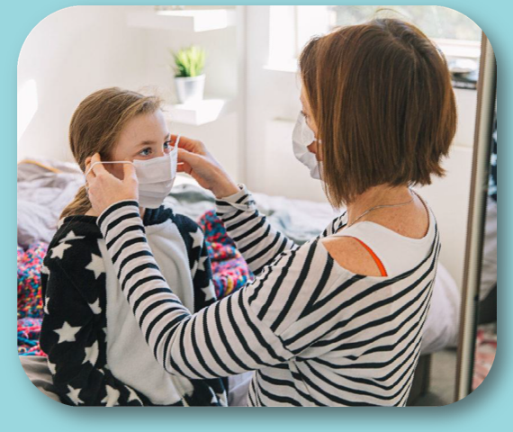

If the face mask feels uncomfortable to me,
I can let someone know.

Together, we can try different ways to make it feel better for me when I wear it.

I can get used to the feeling by practicing wearing it at home.

After coming inside, I wash my hands after I take off my face mask.

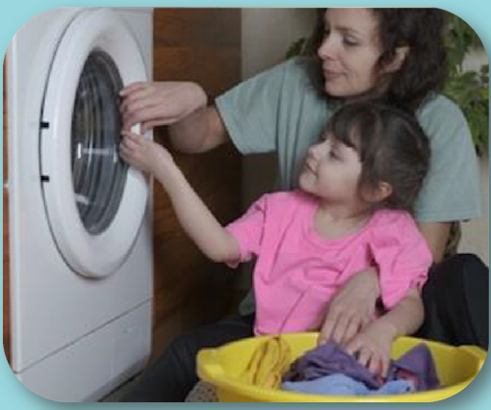

If my face mask is made of cloth, I need to wash it in the washing machine to keep it clean.

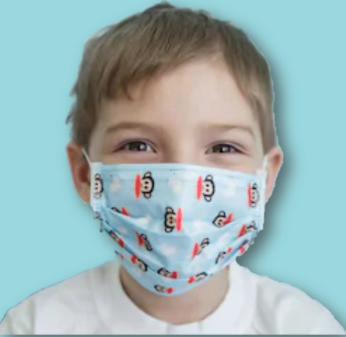
I can wear a face mask next time I leave the house.

Wearing a face mask keeps me from
getting and spreading coronavirus.

It helps keep me and everyone else healthy
and safe.
Try decorating pictures of these face masks in ways that you like.

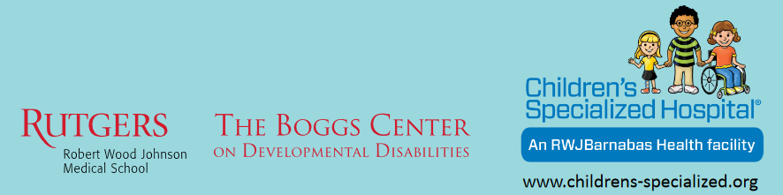

Developed by Michaela Domaratzky, M.D. Candidate, Rutgers Robert Wood Johnson Medical School in partnership with
Children’s Specialized Hospital and The Boggs Center on Developmental Disabilities, New Jersey Leadership Education in Neurodevelopmental and Related Disabilities Program (NJLEND).

Kohls Cares
Through a partnership with Kohl’s Cares, Children’s Specialized Hospital is improving access to care for children with special health care needs.

© 2020 Children’s Specialized Hospital

